SEG2901

CO-OP WORK-TERM REPORT (Summer 2012)

**IBM COGNOS 8 BUSINESS INTELLIGENCE**

Canada Revenue Agency

By

Samira El-Rayyes

6439366

Presented to Professor Thomas Tran

Software Engineering Academic CO-OP Coordinator

University of Ottawa

September 7, 2012

Table of Contents

Abstract4

I. Introduction4

II. IBM Cognos 85

1. Business Intelligence5
2. What is Cognos?6

III. Developing7

IV. Testing8

V. Other Projects9

1. Data Mart9
2. Analysis9

VI. Recommendations10

1. Canada Revenue Agency10
2. CO-OP Program11

VII. Conclusion11

Bibliography12

Appendices13

LIST OF APPENDICES

A: IBM Cognos 8 (Report Studio), Prompt Page - Sample13

B: IBM Cognos 8 (Report Studio), Report Results - Sample14

C: IBM Cognos 8 (Report Studio), Drill-Through - Sample14

***Abstract***

Current technology is allowing for all sorts of services and tools to be brought to life from powerful software to support and simplify the everyday jobs of others. IBM Cognos 8 allows reports to be created by accessing fields and information from the data marts. The main purpose of a report developer is to produce efficient and effective reports to the client. Although the popularity of business intelligence nowadays is not large, there are many uses to it in some of today’s technology industries. My main duties throughout my work term at the Canada Revenue Agency were focused on developing reports that met both the report specification and the expectations of the client. Once a group of reports where developed, I would usually assist other co-workers in testing these reports to ensure that they function just as the client wants them to. Moreover, I performed some tasks in the analysis section of our team. I was dedicated to help create efficient and reliable reports that would be approved by the client. I had the privilege enough to experience employment with the Government of Canada, and I was fortunate enough to see the importance of business intelligence software in the jobs of working in the Canada Revenue Agency I.T. Branch, all while learning how to develop efficient reports and learning the basics of SQL and analysis. My engineering background has been highly beneficial to me while acquiring new technical knowledge. Moreover, I gained interpersonal and team skills by working with influential individuals who allowed me to learn from their expertise, as well as I expanded my network to include experienced professionals. This work term was highly critical to my development as an engineer and a growing member of the high-tech community.

***I Introduction***

For my first COOP work term in Software Engineering at the University of Ottawa, I worked for the Canada Revenue Agency (CRA) from April 30th through August 24th, 2012. I was hired as a Designer/Developer in the CRA Information Technology Branch (ITB) where I reported to Cindy Grant, the Team Lead of the DSS Data Migration team. The CRA delivers world-class tax and benefit administration that is responsive, effective, and trusted, committing to the well-being of Canadians and the efficiency of the Government of Canada.[1] The CRA head office is located in Ottawa, Ontario, with many offices within Ottawa and dispersed all across Canada.

Within the first few weeks with my Team Lead, I was introduced to my team members as well as other teams that the DSS Data Migration team works with. I only had to the opportunity to take part in a full-day workshop held by the CRA ITB headquarters, where all of the new hires at CRA from all over Ottawa got together to learn about the CRA, its history, its goal, its guidelines and the services that they provide.

My performance goals from the beginning of the work term included were to learn efficiency while creating new reports using Cognos 8, the business intelligence software used within the CRA. I was also planning to improve my patience and debugging skills while modifying reports based on report requirements or to meet to needs of the client. Lastly, and certainly not least, my third performance goal for the term was to build on my confidence and improve my public speaking skills, since a lot of our work was based on meeting and communicating with the client.

As learning objectives for my first work term, I wanted to develop a sound competency of the IBM Cognos 8 Business Intelligence software, since that is what my job at the CRA was relied on. I also wanted to enhance my analytical skills, which was to be accomplished by working on the Analysis of data from an old computer system that will be migrated into a new computer system. Finally, I wanted to gather a more thorough understand of what a data mart is, how it works and how the Agency uses it.

Through my day-to-day tasks, I had the opportunity to work with many types of people and experience software development. My main duties included report development, testing and analysis. My primary role was to develop new reports that were needed by the client using IBM Cognos 8 Business Intelligence software. When a group of reports was complete, I would then assist with testing these reports by using common test cases. Lastly, I worked a few times with analysing data and finding anomalies that needed to be brought to the attention of the client.

This report will provide a summary of the tasks required to create detailed reports for the client. I will also briefly explain each project and the challenges that came with each one. This report will also present observations that were made by me, as well as the lessons that I learned through this experience. To conclude, my work term with the CRA has opened my eyes to how business and technology can work together, but that the future of business intelligence may be in jeopardy.

***II Cognos 8***

The DSS Data Migration team focuses on three main stages: ETL (extract, transform, load) process, report writing, and report testing. The most heavily used software is IBM Cognos 8 Business Intelligence, as it is a simple way of developing reports for clients.

1. **Business Intelligence**

Hans Peter Luhn, a researcher for IBM, was the first to use the term “business intelligence” in a 1958 article. His definition of intelligence was as follows: "the ability to apprehend the interrelationships of presented facts in such a way as to guide action towards a desired goal." Businessintelligence has since evolved from the decision support systems (DSS) which started in the 1960s and grew throughout the mid-1980s.

DSS originated in the models created by computers to assist with decision making and planning. From DSS and data marts, business intelligence came to life in the late 80s. Today, business intelligence is defined as the ability for an organization to take all its capabilities and convert them into knowledge. This produces large amounts of information which can lead to the development of new opportunities for the organization. These opportunities, along with an effective strategy, the organization can then benefit from a competitive advantage in the market, which would also lead to stability within the industry in the future.

1. **What is Cognos?**

Cognos was a company creating business intelligence and performance management software, founded in 1969 in Ottawa, Ontario. Cognos was later bought by IBM in January of 2008, however IBM’s business intelligence software released afterwards continued to keep the Cognos name.

IBM Cognos 8 Business Intelligence was released in September of 2005, which put together the features of previous products such as [ReportNet](http://en.wikipedia.org/wiki/Cognos_Reportnet), PowerPlay, Metrics Manager, NoticeCast, and DecisionStream, and later introducing other services such as Report Studio, Query Studio, Analysis Studio, Metric Studio, Metric Designer, Event Studio, Framework Manager, PowerPlay Studio, Analytic Applications, and more. IBM Cognos 8 can be used to view and develop business reports, analyze data, and monitor events and metrics so that they can make reliable decisions.

IBM Cognos 8 is a fairly easy-to-learn and easy-to-use piece of software. It is intranet-based. There is not a programming language used in this software, however, expressions can be written in filters to control the data that is being calculated, used, or displayed. It uses drag-and-drop to build the columns in a report, and it uses the same fashion when pulling fields out from the list provided from the data mart. Cognos uses zero footprint client pieces that connect to a server component. The user experience via the portal (Cognos Connection) and the report authoring tool (Report Studio) is all rendered in a web browser (IE) via HTML and JavaScript. There is nothing to install or deploy to users, making it very popular with IT shops because all management is done on the server end.

During my term with the DSS Data Migration Team, one of my goals was to improve my public speaking and communication skills. It so happens that while I was a CRA employee, there was a dedicated week in which each of the ITB teams in the building give a presentation to the new hires in order to introduce to them what the other teams do, and how they work with other teams. Although I was an attendee at these presentations, I was given the opportunity to present our team along-side my co-worker. At the presentation, I gave an explanation of IBM Cognos 8, as well as I performed a live demonstration of how it works. As nervous as I was to be explaining this to fellow employees who were all older than I was, I found this to be a positive experience. Preparing for this presentation took a lot of effort since I had to be very comfortable with the software and I had to know all of the terminology involved, and through this process I successfully accomplished my goal of improving my communication skills.

Personally, I found this business intelligence software to be relatively simple and a good way to be introduced to this type of development. It provides ease when building the physical look of the report; however, it does not assist you very well when it comes to any logical errors, which is why these reports have to be created patiently and effectively. This being said, it does allow the new developer to learn from their mistakes, which would ultimately improve their developing abilities.

***III Developing***

My primary role on the DSS Data Migration Team comprised of developing reports for the client. The following describes the general procedure to creating client-approved reports.

Firstly, the developers are given copies of the report specifications for a specific group of reports. Reports are grouped by the type of service that you are requesting from the CRA, such as Registered Education Savings Plan (RESP), Registered Retirement Savings Plan (RRSP), and Tax-Free Savings Account (TFSA). Once the specifications are read-through and understood the developers can then commence to create the reports. Specifications can consist of preferences or requirements for many aspects of a report, such as the prompt page, the title, the field names, what the format of the report was going to be (a regular list, or maybe a cross-section table), as well as if there is a prompt page or not for this report. The prompt page on the other hand, would have its own set of requirements, such as what exactly the client wants the user to be able to select, as well as which of these fields are optional and which of them are required.

The next step in developing a report would be to build its main page, also known as the results page. Usually, a general template is used for the title, and sub-titles or the report, as well as the page numbers at the bottom of the page, and the date of which the report was run. Once complete, the easiest part of developing of the report is done! Afterwards, the columns (and rows, if any) of the table have to be inserted in the list. Starting with an empty list, you would drag in the appropriate fields from the side-menu on the left that displays all of the fields available through the data mart. Once a field is dragged into the list, it is then added to the query associated to that list. After inserting all of the appropriate fields into the list, the expressions for the filters can then be written. For example, if the client wants the user to be able to give a range of creation dates of a certain contract, a new variable for the creation date needs to be created in your expression, where you check to make sure that the creation date of the contracts displayed do in fact fall between the creation date range that the user provided.

To build the prompt page, specialized prompt objects can be dragged onto the prompt page. There are many types to choose from, like value prompts, date prompts, search and select prompts, and many more. When a prompt object is dragged onto the screen, an automatic pop-up appears, asking to associate the prompt to a parameter as well as a query.

On the main page as well, the client might require that values given on the prompt page be displayed on top of the list or table. This can be easily done, since all of the prompt objects on the prompt page are associated to a parameter, and all that is then required is to display that parameter at the top of the results page.

Developing reports using IBM Cognos 8 Business Intelligence was probably one of my most enjoyable tasks during my term at the Canada Revenue Agency. I really loved having the ability to create something new, and having the control to manipulate the display of all of this data. Perhaps that I will one day find myself in this task again, as I would really appreciate getting the opportunity to explore the various uses of IBM Cognos 8.

***IV Testing***

Being in the DSS Data Migration team, I had the opportunity to see how reports are given requirements, created, tested, retested and published. After completing the step of creating the reports, I would often assist in testing these reports.

The first thing to verify when testing these reports is that the given report matches the written requirements of the client. Every detail in the requirements must be present in the report, as a single difference will send the report back to get fixed and will therefore need to be retested. We do our best to get the report developed right the first time, as to try to keep to schedule and meet our deadline. There can be requirements for many things, such as which fields are to be displayed in the report, the titles used, the format of the report, even the fonts used.

Another important aspect to verify, if it is part of the requirements, is the prompt page of the report. A prompt is the first page that the client would see when the report is run, which would ask whoever is running the report for optional or required preferences when filtering through the data. Prompts must display the correct options, the correct fields, and must clarify if a field is required or optional. The wrong prompt page would cause for incorrect filters, which would then give unwanted results when the report is run.

Next, the report needs to be verified to ensure that all of the fields exist in the data mart, and to ensure as well that there are no syntax errors. Verifying a report is the equivalent to compiling code; if a report does not verify, it cannot run. One of the most important sections of a report that would be important to check would be the queries. Any field that is used in the report needs to be put in the query; otherwise, an error will occur.

Lastly comes the testing of the logic behind the report, which is more often than not considered the toughest part of developing a report. That being said, it is much easier to make errors on the logical side while developing, as well as it would also be a bit more difficult to identify while testing. To test the logic of a report, multiple test cases must be used.

Testing is not as easy as it looks, although many would argue that testing code or a report must be easier that writing the code or developing the report. However, I can attest that they are two completely different tasks, and each comes with its own challenges.

***V Other Projects***

During my four months at CRA, I had the chance to briefly explore other areas of work at the Information Technology Branch.

1. **Data Mart**

A few times, I have been assigned tasks that involved improving the data mart. Although I was not working directly with the data mart, I performed various tasks that aided my coworkers in improving it.

One of the tasks that were assigned to me was to identify the differences in the table names and field names between the current and previous versions of the same data mart. Consistency is probably the most important factor when it comes to these data marts, as a change in a field name or a table name can hugely affect the functionality of everything else, including the reports. For this reason, the data mart has to be entirely prepared before beginning the development of any reports that are synced to that data mart.

Although I did not get to contribute much to the data mart creation, I learned so many new things about them. My co-workers had kindly allowed me to watch over them as they worked, while even giving me brief explanations of what they were doing, what it meant and how it affected the project. I would love to research more about databases one day, and try to become more involved in my next project that involves databases.

1. **Analysis**

Another area of work where I helped was with the analysis of data. The client would provide us with live data that our lead analyst had to filter through, to make certain that all of the data was compatible with our reports.

For example, I assisted the lead analyst in searching the database for any data that looks funny or also known as “garbage data”. For this, I had to learn how to use Microsoft Access to analyse all of the data. Microsoft Access allowed me to do more than what Microsoft Excel would have let me do. Probably the most significant advantage to Microsoft Access would be that it allows you to use Structured Query Language (SQL). SQL is very useful because it allows one to use simple, standard, and understandable expressions to filter the database. In just a few lines of code, one or more anomalies in a database can be easily found, to be dealt with later on.

During my work on analysis, I came across countless types of anomalies in the databases. Since all of these databases are collected from information that were inputted by regular users, the possibilities or error are endless. For example, if a user fills out a paper form for a Registered Education Savings Plan (RESP), they could easily forget to fill in certain information, or fill it out incorrectly. These mistakes can then be overlooked when in the information is entered in the database, which would cause inconsistency, and often logical errors when using the data loaded in the database with the data mart, hence also causing issues when the reports run.

After all of the anomalies have been found, it is customary to meet with the client and discuss these anomalies with him or her. It is not possible to keep them the way they are, because of the negative effect it will have on the rest of the project. Therefore, a meeting must be had where both the team and the client get to discuss different solutions to each anomaly. Often, it is a problem that the client can fix on his or her own. Other times, we are requested to replace the invalid values with new pre-set values, so that it becomes usable within the data mart.

Personally, I found analyzing data to be my least favourite task that I have performed during this term. For some reason, I found it highly uninteresting and not at all intriguing, however I did very much appreciate getting to know Microsoft Access as well as getting introduced to SQL for the first time.

***VI Recommendations***

After completing my first work term with CRA, I have come up with a few suggestions that could have made my first CO-OP experience slightly easier.

1. **Canada Revenue Agency**

In my opinion, the CRA was a great place to have my first CO-OP placement. Everybody that I have met or worked with was very welcoming and ready to help me with anything I needed.

The most helpful of these people were my coworkers who were working on the same team as me. During the first couple of weeks, a few of them spent numerous hours introducing me to other employees, explaining how the agency works and training me to use Cognos. It was a great environment to learn important skills such as how to work in teams on one project and how to deal with clients and their needs.

As great as it was, I do not believe that the specific position that I was hired for was very much related to my program. There was no coding involved at all, as all I was doing was working with Cognos. For this reason, I would not recommend my position to a more experienced student looking for a placement in software engineering for their second, third, or fourth placement.

1. **CO-OP program**

This being my very first CO-OP work term, I found that the CO-OP office was very welcoming and helpful when it came to finding and preparing for a job. I felt very confident when I first walked into my job and had no issues throughout the term.

I would maybe encourage the CO-OP office to communicate a little more with their students throughout the work term. The advantage to doing so would be that students will keep in mind that CO-OP is a credited program and it would keep them up-to-date with what’s new in CO-OP as well as with upcoming deadlines.

In general, I found the CO-OP office highly helpful. Every time I had a question, I called in and got an answer immediately. It’s a program that I highly recommend!

***VII Conclusion***

In conclusion, IBM Cognos 8 Business Intelligence is clearly an essential in today’s business industry. This software’s amazing capabilities along with its convenient simplicity allow for efficient and effective reports to be created. I do hope that in the future, advances in technology will allow business intelligence to grow and gain popularity in companies. IBM Cognos 8 has proven its uses to the business intelligence world.

Throughout my work term, I was able to relate concepts and knowledge learnt through my classes and personal experience to my daily tasks. Through challenging projects and assignments, I am able to pick up many new lessons and will incorporate such information into future applications. I had the chance to develop many reports for our client as well as test these reports and many others that exercise my new knowledge of Cognos. I would recommend this position to any other software engineering, computer engineering or computer science student looking for a first work term, as it provided an excellent introduction to the workforce.

I would like to sincerely thank all employees of the CRA ITB DSS Data Migration team for granting me the opportunity to be a part of their group and to learn from their expertise. I gained valuable hands-on experience with Cognos as well as I expanded my knowledge about databases in general. Most importantly, I gained interpersonal and team skills by working with a supporting team which dedicated their time to teach me. I valued my time at CRA and hope to be able to carry on all that I have learned into my future projects.

**BIBLIOGRAPHY**

[1] Canada Revenue Agency – Mission, vision, promise, and values, http://www.cra-arc.gc.ca/gncy/prgrms_srvcs/mssn-eng.html, visited August 11, 2012

[2] "A Business Intelligence System", Hans Peter Luhn, *IBM Journal*, 1958

[3] “The Data Warehouse Lifecycle Toolkit: Expert Methods for Designing, Developing, and Deploying Data Warehouses”, Ralph Kimball et al., *Wiley Computer Publishing*, 1998

[4] IBM® Cognos® 8, Main Documentation, *wig_cr.pdf*

[5] Michael Feurer, CRA employee

**APPENDIX A: IBM Cognos 8 (Report Studio), Prompt Page**

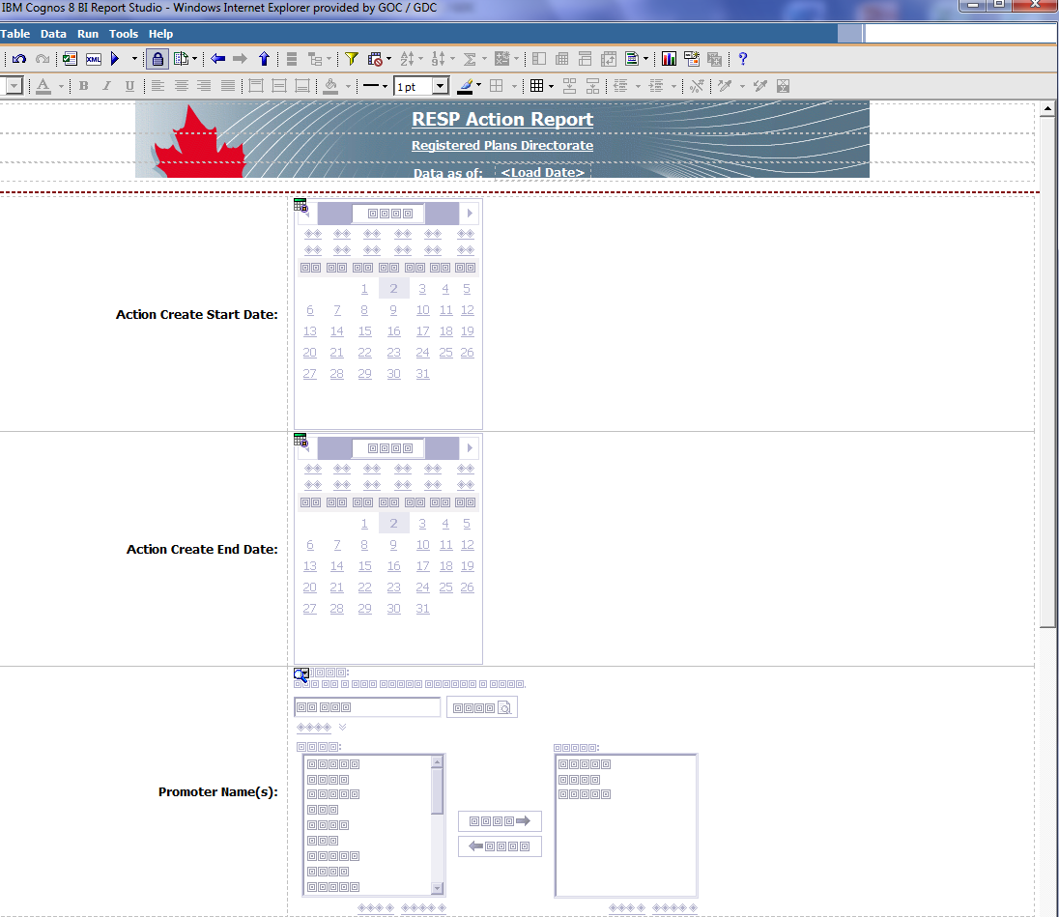

**APPENDIX B: IBM Cognos 8 (Report Studio), Report Results**

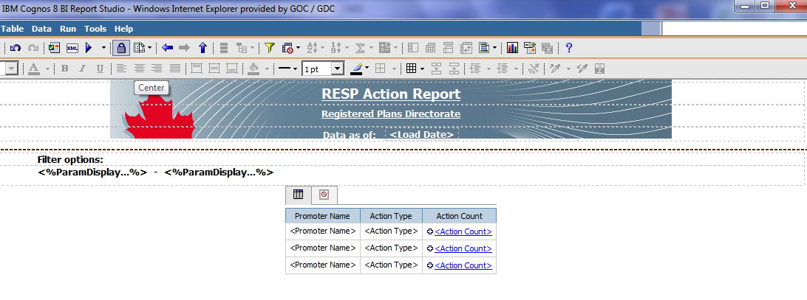

**APPENDIX C: IBM Cognos 8 (Report Studio), Drill-Through**

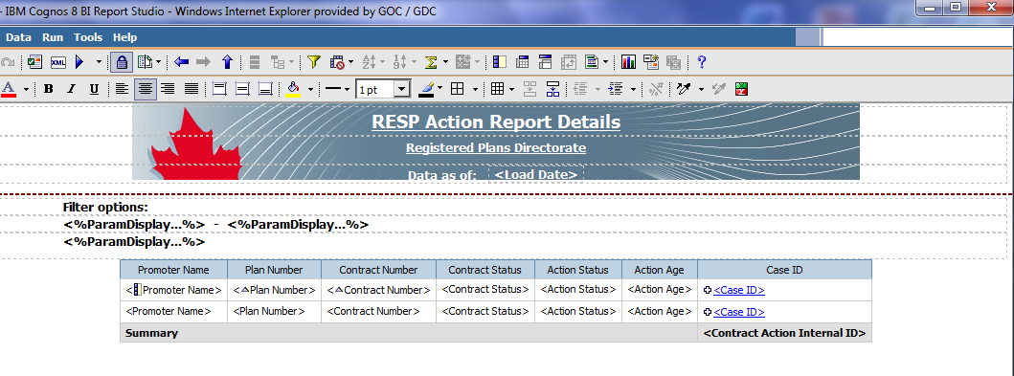

**SUPERVISOR’S APPROVAL**

As supervisor of CO-OP student **Samira El-Rayyes**, I, ________________________, certify that, to the best of my knowledge, this report is entirely the student’s work and is free of confidential information to the extent that it can be read by university faculty members.

Signature ____________________________

Date ____________________________